Cell Isolation from Nasopharyngeal Swabs for scRNA-seq - Illustrated Protocol

Introduction

This protocol can be used to isolate cells from frozen nasopharyngeal swabs. A typical good yield is 50-100,000 cells for each swab.

https://www.protocols.io/view/human-nasopharyngeal-swab-processing-for-viable-si-5jyl8myz9g2w/v1/materials

Samples have been collected using a nasal swab and frozen using a slow-cooling device in 90% FBS + 10% DMSO in a 1.7 mL cryovial in -80°C, stored in LN2.

Materials

**Materials & Reagents for 1 swab** (with overages):

* 2.5 mL of RPMI + 10 mM dithiothreitol (DTT) (made fresh)
* 3.5 mL of Accutase
* 6 mL RPMI
* 8 mL quenching buffer containing RPMI + 10% fetal bovine serum (FBS) + 4 mM EDTA
* 2 mL RPMI + 10% FBS
* 15 mL conical labeled **Tube B** containing 2 mL RPMI (previously 5 mL)
* 1.5 mL tube labeled **Tube B**, empty
* 1.5 mL tube labeled **Tube C**, with 1 mL RPMI + 10 mM DTT
* 1.5 mL tube labeled **Tube D**, with 1 mL Accutase
* 50 mL conical
* 70 µm strainer that fits 50 mL conical
* 1.5 mL tube labeled **Tube E**
* 1.5 mL tube for counting
* 1.5 mL tube for pooling cells (if doing 3 samples, need 1 tube)
* 10 µL trypan
* 1 mL PBS+ 1% BSA
* 15 mL conical for collecting viral supernatant labeled **Tube F**
* 3 cryovials for viral supernatant lysate
* 3 96-well PCR plates or 3 cyrovials for bulk RNAseq lysate
* RLT + 1% 2-mercaptoethanol (BME)

**Equipment**

* Forceps and scissors
* Thermomixer set to 37°C, agitating at 300 rpm
* Hemocytometer slides

Set-Up

1. Record sample characteristics in Table 1



1. Prepare 50 mL conicals with necessary reagents:
   * RPMI + 10 mM DTT
   * Accutase
   * RPMI + 10% FBS + 4 mM EDTA (quenching media)
   * RPMI + 10% FBS

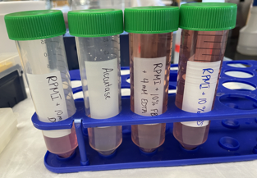

1. 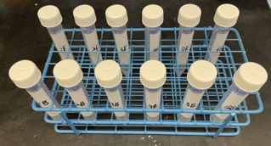Label 2 sets of 15 mL conicals **(Tube B & Tube F)**. Pre-fill **Tube B** with 2 mL RPMI
2. Label 4 sets of 1.5 mL tubes **(Tube B, Tube C, Tube D, Tube E)** Pre-fill **Tube C** with 1 mL RPMI + 10mM DTT and **Tube D** with 1 mL Accutase

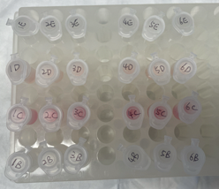

1. Label 1 set of 50 mL tubes for filtering at later step (can set aside for beginning of protocol)

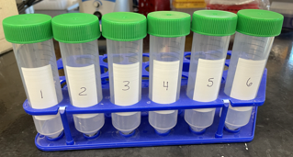

Complete Set-Up

Timing

Fill out timing chart at indicated steps of protocol:



Procedure

Tube A (the cryovial)

1. Rapidly thaw cryovial in thermal block set to 37°C.
2. Remove swab from cryovial using forceps.
3. Place swab in **Tube B** (15 mL conical), dip briefly to rinse swab
4. Move swab from **Tube B (**15 mL conical) to **Tube C.** Trim swab handle using scissors if necessary. (continue below **Tube C**)
5. Transfer liquid in **Tube A** to **Tube B** (15 mL conical)
6. Using ~ 1 mL RPMI from **Tube B** (15 mL conical), wash **Tube A**. Collect washing in **Tube B** (15 mL conical) (continue below **Tube B)**
7. Discard **Tube A**

Tube B

1. Centrifuge 15 mL conical **Tube B** at 400g for 5 minutes at 4°C
2. Remove supernatant with serological or P1000
3. Place supernatant in **Tube F**
4. Resuspend pellet in 1 mL RPMI + 10 mM DTT
5. Transfer suspended cells from **Tube B** (15 mL) to **Tube B** (1.5 mL). Discard empty 15 mL conical.
6. Place **Tube B** 1.5 mL eppendorf on thermomixer (37°C, 300 rpm)
7. Incubate for 15 minutes
8. Centrifuge **Tube B** (1.5 mL) at 400g for 5 minutes at 4°C
9. Remove supernatant with P1000 pipette
10. Resuspend pellet in 1 mL Accutase
11. Place **Tube B (**1.5 mL) on thermomixer (37°C, 300 rpm)
12. Incubate for 30 minutes

Tube C

1. Place **Tube C** on thermomixer (37°C, 300 rpm)
2. Incubate for 15 minutes
3. Place swab in **Tube D** (continue below **Tube D**)
4. Centrifuge remaining liquid at 400g for 5 minutes at 4°C
5. Remove supernatant with P1000 pipette
6. Place supernatant in **Tube F**
7. Resuspend pellet in 1 mL Accutase
8. Place **Tube C** on thermomixer (37°C, 300 rpm)
9. Incubate for 30 minutes

Tube D

1. Place **Tube D** on thermomixer (37°C, 300 rpm)
2. Incubate for 30 minutes
3. Take 10X reagents out at this step so that they have time to equilibrate to the appropriate temperature

After **Tube B**, **Tube C**, and **Tube D** have finished their 30 minute incubation:

*Note: in practice, we wait until all tubes have finished and synched up and leave tubes on incubation for longer than 30 minutes (maximum 50 minutes).*

1. Place 70 µm filter in 50 mL conical
2. Wet filter with 3 mL quenching buffer (RPMI + 10% FBS + 4 mM EDTA)
3. Pipette contents of **Tube B**, **Tube C**, and **Tube D** onto filter (Do not discard original tubes)
4. Use 1 mL of fresh quenching buffer to wash each **Tube B**, **Tube C**, and **Tube D**. Manually agitate the swab in **Tube D** in the quenching buffer with forceps to ensure full rinse
5. Add quenching buffer from washes to filter. Discard **Tubes B, C,** and **D.**
6. Wash filter with additional 2 mL quenching buffer
7. Discard filter, cap 50 mL conical
8. Centrifuge 50 mL conical at 400g for 10 minutes at 4ºC

*It will likely be very challenging to see a pellet in the 50 mL conical at this point.*

1. 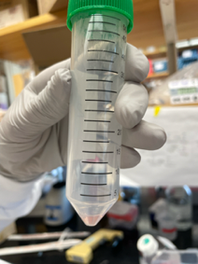Remove supernatant with serological. Leave ~500 µL in the bottom of the tube

Example residual volume

*Remove supernatant carefully at this step! You don't want to pipette up your cells but you will need to add the volume you leave in this 50 mL conical and 1 mL RPMI + 10% FBS to a 1.5 mL tube in the next steps, so try not to exceed 500 µL residual volume.*

1. Add 500 µL RPMI + 10% FBS to the tube to resuspend cells.
2. Transfer resuspended cells (~1 mL) to **Tube E** (1.5 mL tube)
3. Wash 50 mL conical with additional 500 µL RPMI + 10% FBS. Transfer washing to **Tube E**
4. Centrifuge **Tube E** at 400g for 5 minutes at 4°C
5. A picture containing indoor, person

   Description automatically generatedRemove supernatant with P1000 pipette
6. Resuspend pellet in 1 mL RPMI + 10% FBS

*At this point, you should be able to see a reasonably-sized pellet!*

1. Centrifuge **Tube E** at 400g for 5 minutes at 4°C
2. Resuspend pellet in 200 µL RPMI + 10% FBS

Example pellet in Tube E after centrifuging.

Count cells from **Tube E**

1. In 1.5 mL tube, add 10 µL trypan
2. Add 10 µL cells from **Tube E** to 1.5 mL tube containing trypan blue.
3. Pipette to mix cells in trypan blue, transfer 10 µL to hemocytometer port
4. Count viable cells across 4 quadrants
5. Record total cell number and cell concentration
6. Take photo of cells at 4x

Representative hemocytometer images at 4X

Prepare cells for 10X

1. Prepare 1.5 mL tubes for each pool
2. For each sample, add "Volume Necessary for Desired Number of Cells" from Table 3 to correct pool
3. Pipette cells to mix
4. If volume of pool is > 100 µL, centrifuge cells at 400g for 5 minutes, then resuspend in 500 µL PBS + 1% BSA and proceed to next step. If volume of pool is < 100 µL, add 500 µL PBS + 1% BSA directly to pool and proceed to next step.
5. Centrifuge cells at 400g for 5 minutes
6. Resuspend cells in 43.3 µL PBS + 1% BSA (Total volume of cell suspension + water on page 27 of 10X Protocol)
7. Add 43.3 µL of cell suspension directly to 31.9 µL master mix (Step 1.2b of 10X Protocol)
8. Proceed with instructions in 10X Protocol to load the chip and run the controller (through Step 1.3)
9. At Step 1.4f, take a picture of the GEMs in the pipette tips

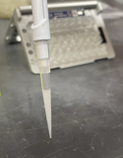

Example photo of successful run

**Tube F** Processing

*In* ***Tube F****, you should have 2 mL from original RPMI + 0.5-1 mL from swab cryopreservative + 1 mL from tube C supernatant = ~4 mL total*

1. Add 1 mL RLT + BME (or Seq-Well complete lysis buffer) to **Tube F.**
2. Distribute contents of **Tube F** into 3 cryovials per sample

*You can save time here by labeling cryovials/plates for viral and bulk lysates the day before!*

1. Snap freeze on dry ice
2. Store at -80°C

Lysates for Bulk RNA-seq

1. For each lysate, add "Volume Necessary for Each Lysate" from Table 7 to one well of a 96 well PCR plate according to the Lysis Storage Plate map.

*Typically, we aim to store 3 lysates per sample. To do so we label 3 plates and fill 1 well per sample in each plate, if cell numbers allow.*

1. Seal plates and centrifuge at 400xg for 5 minutes
2. Aspirate media

*It may be difficult to see a pellet here, so it’s okay to leave some residual volume before resuspending in lysis buffer in next step.*

1. Resuspend cells in 50 µL Lysis Buffer (RLT + 1% BME). Mix with pipette. Bubbles are okay here.
2. Seal plate with foil seal and spin down briefly.
3. Place plate on dry ice for 15-20 minutes to snap-freeze lysate.
4. Store at -80°C until ready to use.